Anik Shaikh

Enrollment no – 23162121021

Batch 31

OOP

Practical 3

**Q – 1 Arithmetic operator:-**

* : Implement a simple financial calculator that performs basic arithmetic operations (addition, subtraction, multiplication, division) to calculate interest, loan payments, and savings.
* : +, -, *, /

Code:

import *java*.*util*.*Scanner*;

*public* *class* prac_3 {

*public* *static* void *main*(String[] args) {

        Scanner scanner = *new* *Scanner*(System.*in*);

        System.*out*.*print*("Enter first number: ");

        double num1 = scanner.*nextDouble*();

        System.*out*.*print*("Enter second number: ");

        double num2 = scanner.*nextDouble*();

        System.*out*.*println*("Addition: " + (num1 + num2));

        System.*out*.*println*("Subtraction: " + (num1 - num2));

        System.*out*.*println*("Multiplication: " + (num1 * num2));

*if* (num2 != 0) {

            System.*out*.*println*("Division: " + (num1 / num2));

        } *else* {

            System.*out*.*println*("Division: Cannot divide by zero");

        }

        System.*out*.*print*("Enter principal amount: ");

        double principal = scanner.*nextDouble*();

        System.*out*.*print*("Enter interest rate (as decimal): ");

        double rate = scanner.*nextDouble*();

        System.*out*.*print*("Enter number of years: ");

        int years = scanner.*nextInt*();

        double interest = principal * rate * years;

        System.*out*.*println*("Simple Interest: " + interest);

        scanner.*close*();

    }

}

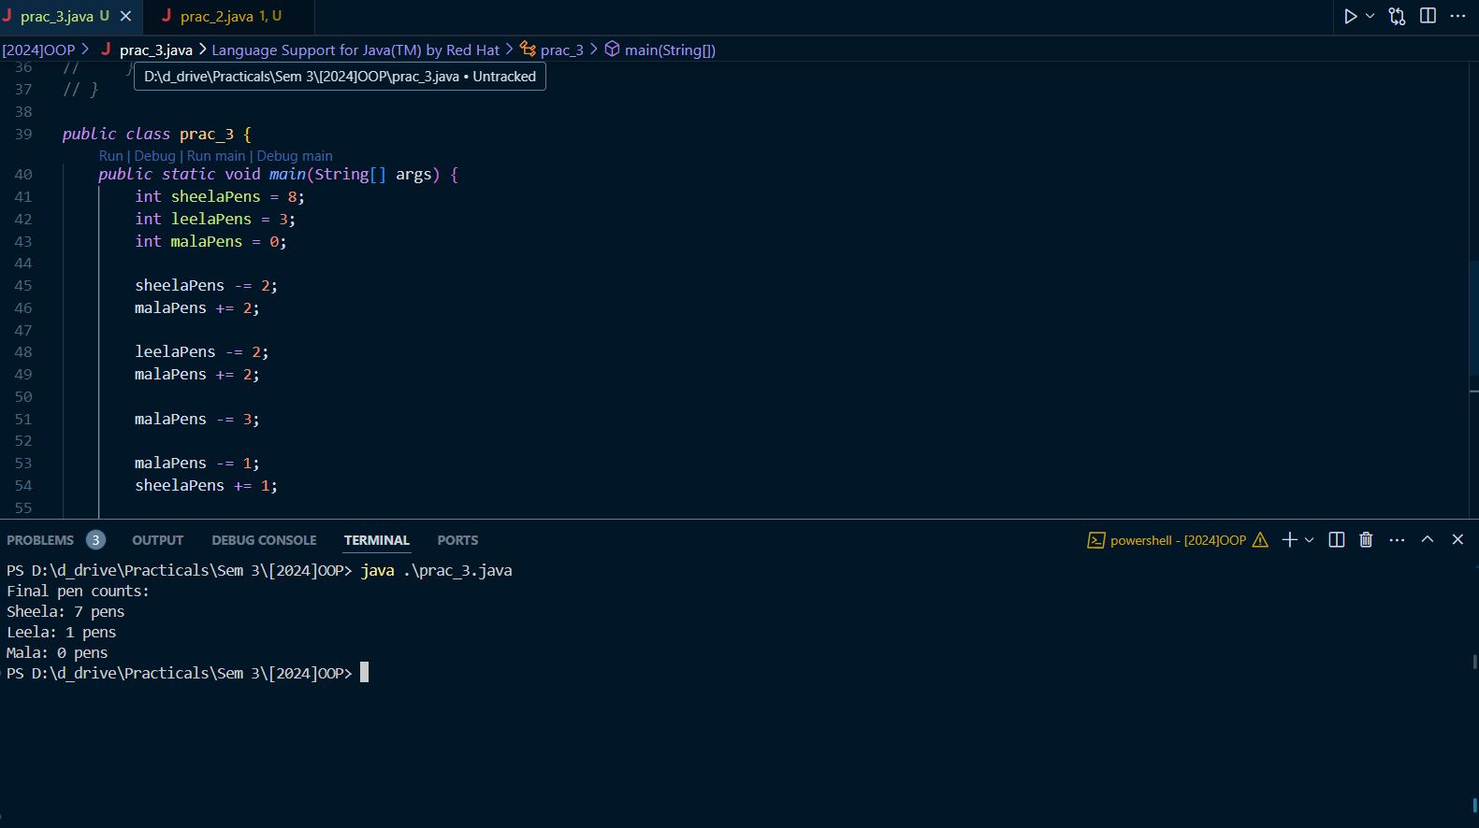

Q – 2 **Assignment operator:-**

* imagine sheela ,leela and mala are 3 good friends sheela have 8 pens, leela have 3 pens and mala have nothing . sheela gave 2 pens to mala, leela gave 2 pens to mala , mala lost 3 pens and one pen gave to sheela , how many pens they have each in their bags, write a java programm using assignment operator

Code:

*public* *class* prac_3 {

*public* *static* void *main*(String[] args) {

        int sheelaPens = 8;

        int leelaPens = 3;

        int malaPens = 0;

        sheelaPens -= 2;

        malaPens += 2;

        leelaPens -= 2;

        malaPens += 2;

        malaPens -= 3;

        malaPens -= 1;

        sheelaPens += 1;

        System.*out*.*println*("Final pen counts:");

        System.*out*.*println*("Sheela: " + sheelaPens + " pens");

        System.*out*.*println*("Leela: " + leelaPens + " pens");

        System.*out*.*println*("Mala: " + malaPens + " pens");

    }

}

